DEPOSIT (REFUNDABLE) FOR NON-OFFICIAL CONTRACTORS
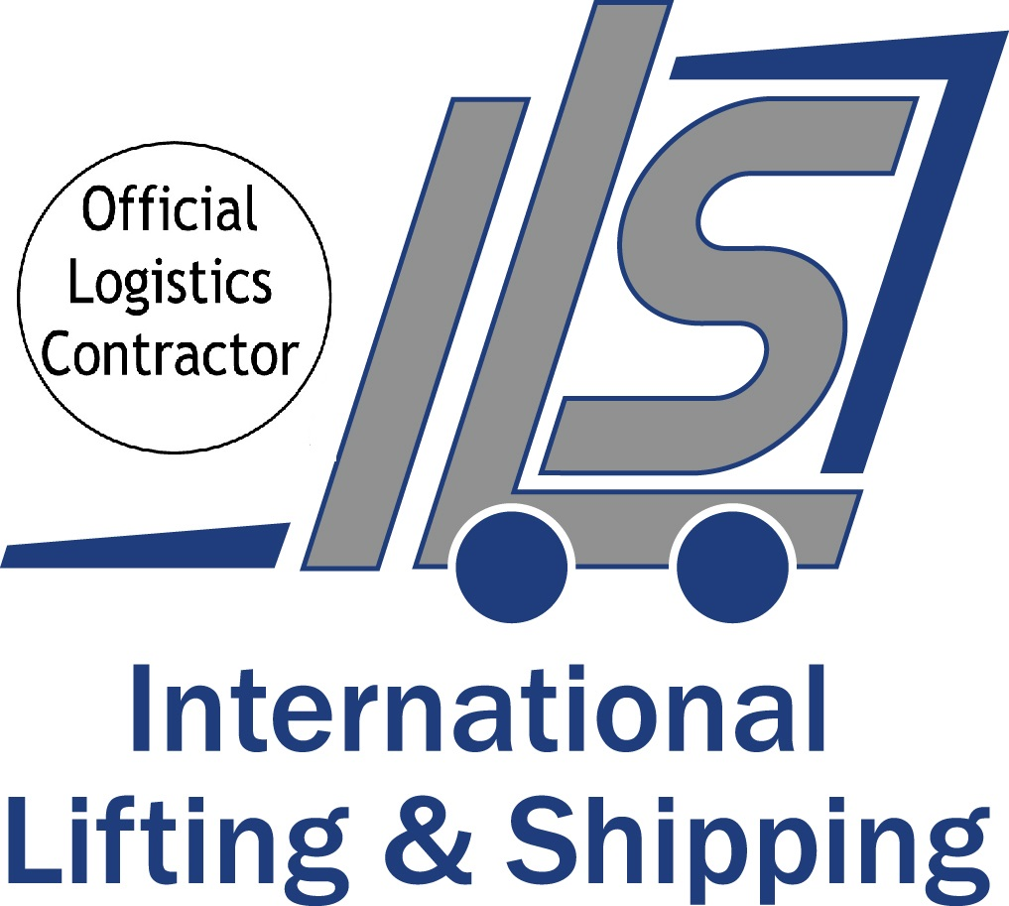


Deadline Date for Return: Friday 8th August 2025

Stand Name: |  | Stand No:

Contractor Name:

Payee Company Name:

Address:
 |  | Post code
On site contact Name/ No: |  | VAT No

Email address

This deposit system has been created by Labelexpo Europe / Informa and is to ensure the contractor is performing to the expected level and the stand space is left undamaged and free from waste at the end of the event.

The contractor will only be permitted to commence work in the hall when the Organiser has approved the stand design, and the deposit has been received by ILS.

The refundable deposit is based on sqm of your stand.

0-50sqm €500.00 euros 51 – 200sqm €1000.00 euros 201sqm + €1500.00 euros

Upon receipt of your deposit form, ILS will send you the charges based on the sqm of your stand for payment which must be received by the deadline date.

Important:
At the end of the event when your stand is packed and loaded the Labelexpo Hall Manager must sign your stand space off as undamaged and free from excess waste. ILS will then be notified by the Organisers that your deposit can be refunded.

Please note that any bank charges ILS incur to receive/ refund the deposit will be deducted from the final refund.

Please provide details of a Euro Currency bank account you wish to be refunded back to:

Beneficiary Name:
Bank Name:
Bank address:
Swift Code: |  | Account No:
Iban No:

Please return completed form by Friday 8th August 2025

International Lifting & Shipping
Kelly Gouveia
Email: kelly@i-l-s.co.uk

International House, Colonnade Point, Central Boulevard, Prologis Park, Coventry CV6 4BU
Tel: +44 (0) 24 7633 7955 Email: lift@i-l-s.co.uk Website: www.ils-logisticslive.co.uk

All business is undertaken subject to the current edition of our Conditions of Trading, copies of which are available upon request. These conditions contain provisions which
limit and/or exclude our liability and should be read carefully. Without prejudice to the generality of those conditions, please note that in no circumstances will we accept responsibility for goods left unattended at any time, whether on a stand or in an open store or otherwise (All stores deemed open unless expressly stated otherwise)

