Performance Bond (Refundable) for Non-Official Contractor
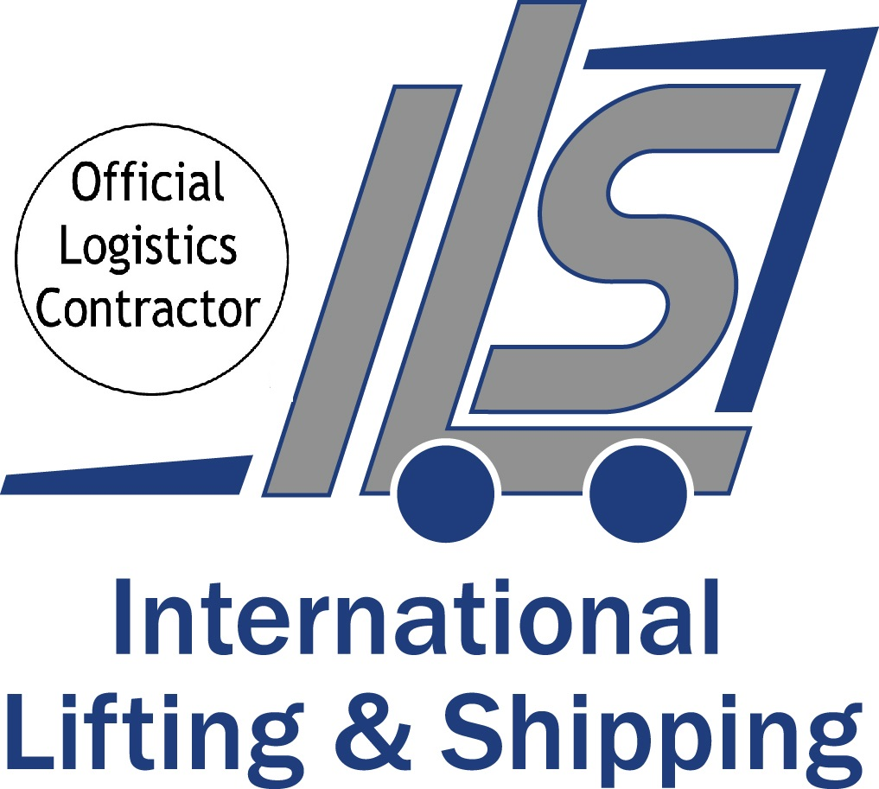


Deadline Date for Return: Friday 4th August 2023

Company Name

Address
 |  | Post code
Stand Name |  | Stand/ Hall No
On site contact  Name/ No |  | VAT No

Email address

Contractor Name

Address
 |  | Post code
On site contact  Name/ No |  | VAT No

Email address

I agree to the terms and conditions of ILS | Print name

To view our Conditions of Trading please click here and our data privacy policy please click here or visit our website www.i-l-s.co.uk

When the nominated Contractor is not an Official Contractor, the Contractor will be required to prepare the Performance Bond. This is a refundable deposit based on the contracted space size at Labelexpo Europe 2022.

The non-official Contractor will only be allowed to commence work in the exhibition hall when the Organiser approves the stand design and International Lifting & Shipping receive the necessary Performance Bond deposit payment. This is to ensure that the rules and regulations are adhered to and to cover any damages arising directly or indirectly from infringement. This is without prejudice to any additional claims the Organisers may have on the Contractor if the damages exceed the deposit.

0-50sqm €500.00 euros 51 – 200sqm €1000.00 euros 201sqm + €1500.00 euros

Upon receipt of your form, a pro-forma invoice for payment will be emailed along with payment and refund instructions. Please note that bank charges we incur to receive and refund the Performance Bond will apply accordingly and will be deducted from the final refund.

Please return completed form by Friday 4th August 2023

Kelly Gouveia - International Lifting & Shipping
Email: kelly@i-l-s.co.uk

International House, Colonnade Point, Central Boulevard, Prologis Park, Coventry CV6 4BU
Tel: +44 (0) 24 7633 7955

All business is undertaken subject to the current edition of our Conditions of Trading, copies of which are available upon request. These conditions contain provisions which limit and/or exclude our liability and should be read carefully. Without prejudice to the generality of those conditions, please note that in no circumstances will we accept responsibility for goods left unattended at any time, whether on a stand or in an open store or otherwise (All stores deemed open unless expressly stated otherwise)

