

SIDDHARTHA LOGISTICS CO. PVT. LTD.


International Shipping Instructions
Label Expo India -2022
Venue: India Expo Mart/ Expo Centre, Greater Noida
City : Noida, U.P
Country: INDIA
Period: 10th-13th November, 2022.
Kindly read the information & instructions compiled herein carefully & comply with the guidelines to ensure correct documentation for smooth dispatch of goods under ‘Temporary and Permanent’ import for Exhibitions in India.

Non-compliance will cause un-necessary delay in custom clearance & additional expenses.

`

INDEX

Sr. No. | PARTICULARS | PAGE NO.
1. | Important Information (must read) | 1
2. | Sea freight – Schedule & Consignee | 2
3. | Air freight – Schedule & Consignee | 3
4. | Consolidated shipments of more than one exhibitor. | 3
5. | Documentation (Sea / Air) | 4
6. | Insurance | 5
7. | Bank Guarantee for Temporary Import | 5
8. | Embassy / Diplomatic Guarantee for Temporary Import | 5
9. | ATA carnet for Temporary Import | 5
10. | Packing of Exhibits | 5
11. | Case Marking | 6
12. | Formalities after Closure of the Exhibition | 6
13. | ANNEXURES
 | Annexure – I : Letter of Authorisation for ATA Carnet | 7
 | Annexure – II : Letter of Authorisation for Custom | 8
 | Annexure – III : Letter of Authorisation for Airline | 9
 | Annexure – IV : Invoice cum Packing List Format | 10
 | Annexure –V : List of documents for completing the commercial clearance after the show | 11

- IMPORTANT INFORMATION

1.1 The facility of Temporary Importation into India is extended to only I.T.P.O. or Government of India Approved shows.

1.2 Exhibitors who have paid for the stand space in foreign currency to the organizers can avail the Temporary import facility. The organizers then issue a Certificate / Letter of Participation to confirm that the shipper/owner of the exhibits is an exhibitor at the event. This certificate is mandatory for custom clearance. For exhibitors from Taiwan & China, Afghanistan, Iran Iraq , Sudan MEA (Ministry of External Affairs) Clearance is required as well.

1.3 The Exhibits imported on temporary basis are allowed to be displayed only for a particular show. Exhibitor intending to use the same exhibits for another show in India must obtained prior permission from the Indian customs & must be a bona fide participant at the next event. To obtain this permission we, Siddhartha Logistics will require a letter from the exhibitor, addressed to customs.

1.4 Temporary import into India is possible either with the help of ATA Carnet, Bank Guarantee or Embassy Guarantee. As per Indian Custom rule, the shipment can remain in India for 6 months from the date of arrival. Exhibitors intending to extend the period will have to approach respective Bank or Embassies for guarantee extensions and further to Indian Customs.

1.5 The regulations for temporary import are complex and their application is strictly enforced. The goods must remain in our control until these are re-exported or duty is paid.

1.6 Please note Consumable items such as Gift items, Give-aways, Small value samples Literature, Catalogues for free distribution, etc are dutiable and should be included in your guarantee value to Indian customs.

1.7 All documentation including ATA Carnet must be in the English Language.
No other language is acceptable.

1.8 Do not send literature; give aways or consumables alongwith ATA Carnet.

1.9 If exhibitors choose to ship directly to New Delhi ICD by sea or New Delhi by air must note that shipments on Temporary basis & Consumables must be packed, invoiced & shipped separately. Also note all goods should as per ATA Carnet item list / CCICPL if the goods don’t match with shipping documents then we are not responsible in delay or hold the goods by custom authority amd any penalty imposed.

1.10 DO NOT mix different kinds of Guarantees on One AWB or One Bill of Lading. All Original Bill of Lading to be endorsed by the exhibitors on reverse.

1.11 It is imperative to complete each custom entry made at the time of import, either by completing re-export formalities or consumption entries (permanent import by paying duty), which will be charged accordingly.

  - Government levies – Service Tax shall be applicable on handling & agency charges.
1.

- SEA FREIGHT

  - Routing & Time Schedule
ROUTING | ARRIVAL DEADLINES
FCL shipments ICD, Tuglkabad, New Delhi  Prior to opening of show date or your work Commencement date on site | 02 Weeks.
LCL shipments ICD, Patparganj, New Delhi.  Prior to opening of show date or your work Commencement date on site. | 3 Weeks
Final destination / port of discharge must New Delhi ICD. Freight must be Prepaid.

IMPORTANT:

- De-stuffing of LCL containers at port is done by the shipping line. We have no control over this operation & we can start custom clearance only once cargo is de-stuffed. It is important to notify the shipping line of the shipment required date to avoid delay.

- If the container is required on site & to be retained till re-export, we must be informed prior to arrival of the container in order to prepare necessary documents & arrange the same at exhibitor cost.

2.2 Sea Freight Consignee

FCL & LCL directly to New Delhi ICD & Break Bulk to Mumbai Port on Master Bill of Lading - Single Exhibitor/ Single Category:

Consignee:
Siddhartha Logistics Co. Pvt. Ltd.
On behalf of “Exhibitors Name : _________________”
Name of Exhibition ………………………., Hall No. ……….. Stand Number ………..:
Dates …………….., Venue:………………………., INDIA.
Notify:

For Shipment on ATA Carnet or Bank Guarantee:
SIDDHARTHA LOGISTICS CO. PVT. LTD.
315, Ansal Tower, 38 Nehru Place , New Delhi-110019, INDIA
Tel : 0091-11-26422237/41090609
Email: anildelhi@siddharthalogistics.com/
Contact : Anil Kumar - +91-9910398813
For Shipment on Embassy or Diplomatic Guarantee:
Embassy Name
&
Exhibitor Name
C/o. Siddhartha Logistics Co. Pvt Ltd

[complete address as in above notify]
2.

3. AIRFREIGHT
  - Routing & Time Schedule
ROUTING | ARRIVAL DEADLINE
Shipments directly to New Delhi airport. | 12 Working Days  Prior to opening of show date or your work Commencement date on site

  - Air Freight Consignee : For single Exhibitor/Category on direct Master AWB
AWB Consignee:
Siddhartha Logistics Co. Pvt. Ltd.
On behalf of “Exhibitors Name : _________________”
Name of Exhibition ………………………., Hall No. ……….. Stand Number ………..:
Dates …………….., Venue:………………………., INDIA.
Notify:
SIDDHARTHA LOGISTICS CO. PVT. LTD.
315, Ansal Tower, 38 Nehru Place , New Delhi-110019, INDIA
Tel : 0091-11-26422237/41090609
Email: anildelhi@siddharthalogistics.com/
Contact : Anil Kumar - +91-9910398813

WE STRONGLY RECOMMEND THE USE OF DIRECT MASTER AWB

IMPORTANT:- Please note in order to collect “Delivery Order” from the Airline, an Authorization letter addressed to the Airline on the Exhibitors Letter Head in favour of Siddhartha Logistics Co. Pvt Ltd would be required. Please fax/email us the same prior to arrival of shipment and send the original along with the shipment attached to the AWB (please see Annexure - III).

SPECIAL INSTRUCTIONS : Please mention following clause on AWB :

“All Documents and Delivery Order pertaining to this shipment may be handed over to Siddhartha Logistics Co. Pvt. Ltd. without any further authorization”

4. Consolidated Shipments of more than One Exhibitor – by SEA/ AIR.
MAWB/MBL must indicate “CONSOLIDATION AS PER MANIFEST” Manifest must be attached to the Master AWB/ Master BL.
MAWB/MBL Consignee:
SIDDHARTHA LOGISTICS CO. PVT. LTD.
[complete address as in above notify]
Notify:
SIDDHARTHA LOGISTICS CO. PVT. LTD.
[complete address as in above notify]

Individual house AWB/BL must be issued per exhibitor per consignment per guarantee / ATA Carnet
HAWB/ HBL Consignee:
“Exhibitors Name : _________________”
Name of Exhibition ………………………., Hall No. ……….. Stand Number ………..:
Dates …………….., Venue:………………………., INDIA.
Notify:
SIDDHARTHA LOGISTICS CO. PVT. LTD.
[complete address as in above notify]
3.

5. DOCUMENTATION - SEA / AIR SHIPMENTS
The Invoice cum Packing lists must be in English only and must indicate all the details given below. Invoice value MUST be CIF India (please see Annexure IV).

Description of Items | Quantity & Type
Serial numbers & model numbers | Package Weight & Dimensions
Unit Price/ Individual item values | Total C.I.F. value
Country of Origin | HS Code

5.1 Consignee for Commercial Invoice / Packing List:
Consignee:
Siddhartha Logistics Co. Pvt. Ltd.
On behalf of “Exhibitors Name : _________________”
Name of Exhibition ………………………., Hall No. ……….. Stand Number ………..:
Dates …………….., Venue:………………………., INDIA.

  - Shipping Documents:
SEA | AIR
- Bill of Lading (3 original & 3 copies)  [Duly stamped & signed by Exhibitor] OR CAN BE EXPRESS RELEASE (Preferred).  - Cargo / Container Manifest in case of  FCL / LCL shipments  - ATA Carnet original or Invoices - (05 copies)  - ATA authorization letters to handle on your behalf–Annexure I (2 copies) & Packing list (2 copies)  - Product catalogue/ Technical write-up  - Organizers letter of participation & Copy ITPO  - sponsor letter from concern ministry / state govt. or central govt  - MEA & MHA NOC for Taiwan, China, Afghanistan, Sudan, Iraq & Iran exhibitor  - Insurance Certificate and contact details of Insurance surveyor company in India  - Phytosanitory Certificate (for wooden packing)  - Instructions for container to be moved to site  (If required)  - Copy of UP Sale tax permission  - Authorization Letter to Custom -  Annexure - II (1 Original)  Above Documents should be couriered to us as soon as the Vessel sails :  Siddhartha Logistics Co. Pvt Ltd  315, Ansal Tower, 38,  Nehru Place , New Delhi -110019  Tel : 0091-11-26422237/41090609  Kind Attn: Anil Kumar (Mobile No. 0091-99103 98813)  Documents must reach us 14 days prior to arrival of shipment at New Delhi ICD. | - Air Way Bill  - Cargo Manifest in case of shipment under Consolidation (2 Original)  - ATA Carnet original or Invoices –  (05 copies)  - ATA authorization letters to handle on your behalf–Annexure I & Packing list (2 copies)  - Product catalogue/ Technical write-up  - Organizers letter of participation & copy of ITPO approval.  - sponsor letter from concern ministry / state govt. or central govt  - MEA & MHA NOC for Taiwan, China, Afghanistan, Sudan, Iraq & Iran exhibitor  - Insurance Certificate and contact details of Insurance surveyor company in India  - Phytosanitory Certificate (for wooden packing)  - Copy of UP Sale tax permission  - Authorization letter to Customs & Airline – Annexure II & III  (1 Original - Each)  All the above mentioned documents must be attached to the Airway Bill.  We must receive pre-alert with flight & AWB details prior to dispatch of your shipment.  NOTE: Without the Original Documents Custom Clearance cannot be done.
All documents must be e-mailed for approval/confirmation before sending originals.
Email: anildelhi@siddharthalogistics.com
4.

- INSURANCE

We strongly recommend exhibitors to insure their goods from their premises to stand/ Hall, duration of exhibition / storage and till return. Siddhartha Logistics will not be responsible for any pilferage or damage.

- BANK GUARANTEE

If Guarantee should be arranged through your bank then it must be countersigned by a nationalized bank as a surety against settlement of all duties and taxes, which may become payable if all items imported, are not accounted for. The Bank Guarantees must be in place prior to arrival of your shipment in India (contact us for further details).

Siddhartha Logistics can arrange the Bank Guarantee on your behalf to the Indian Customs for which the charges will be applicable as per tariff.

- EMBASSY / DIPLOMATIC GUARANTEE

Foreign Embassies in India are well versed to issue guarantees on behalf of exhibitors and it must be arranged by the exhibitor or the National Group Sponsor.

Exhibitor must inform the Embassy to handover the guarantee to Siddhartha Logistics on request for presentation to customs.

- ATA CARNET

India is signatory to the protocol on ATA Carnet system for a long time and ATA Carnet is accepted by Indian Customs in lieu of Bank or Embassy Guarantee for Temporary Import. This document is obtained by the exhibitor from the Chamber of Commerce at the country of Origin. A Letter of Authorization in favor of Siddhartha Logistics Co. Pvt Ltd from the exhibitor is must to handle ATA Carnet on behalf of the Exhibitor/Holder. (Please see attached format under Annexure I).

- PACKING OF EXHIBITS

Please note that the exhibits are handled repeatedly at many points by different agencies before it reaches the final destination and are subject to rough handling sometimes which is inevitable. The exhibits are at times placed in open-air storage at the exhibition center before and after the exhibition or at port/airport even without a tarpaulin. It is strongly recommended that the Exhibitor should take necessary precautions against damage and rain, especially when the return exhibits are to be packed with original packing materials (the case as well as aluminum foil, plastic covers etc. may be damaged already during unpacking).

The exhibitor shall be responsible for the consequences of improper packing.

For return exhibits Siddhartha Logistics has special service for Corrosion Resistant/ Vacuum Packing & available upon request.

CONSUMABLES AND TEMPORARY EXHIBITS UNDER ATA CARNET OR BANK OR EMBASSY GUARANTEE SHOULD BE PACKED SEPARATELY:
5.

11. Case Marking
Each case should be clearly marked as follows:
EXHIBITORS NAME:
C/O. SIDDHARTHA LOGISTICS CO. PVT. LTD.
NAME OF EXHIBITION, DATES & VENUE:
STAND NUMBER:
CASE NUMBER (Must be same as in packing list/invoice):

12. FORMALITIES AFTER CLOSURE OF THE EXHIBITION:-

12.1 Sale of exhibits: - ON Request

12.2 Destruction of Materials

It will be the discretion of Customs Authority and can only be permitted once all details of the material are furnished. Please contact us for further procedure.

12.3 Goods lost or not accounted for

Please note that any goods/exhibits lost, consumed or given away which are under temporary import will have to be reported or accounted for to Customs & all duties, Taxes & Penalties (if Any) will be levied, payable by exhibitor.

13. ANNEXURES FOR COMPLETION

Annexure – I : Letter of Authorization for ATA Carnet

Annexure – II : Letter of Authorisation for Custom

Annexure – III : Letter of Authorisation for Airline

Annexure – IV : Invoice cum Packing List Format
6.

ANNEXURE - I

LETTER OF AUTHORISATION – ATA CARNET

It is a must to have a letter of authorisation in favour of Siddhartha Logistics Co. Pvt Ltd to process / handle the ATA Carnet at Customs, from the exhibitor or from ATA Carnet holder or both in the following format on Company headed paper. (02 ORIGINALS)

TO WHOM IT MAY CONCERN

I / We, Ms. / Mr. (Name of the signatory) ………………………………………………………………
Of (Company Name) ……………………………………………………………………………………… hereby authorise / appoint M/S. Siddhartha Logistics Co. Pvt Ltd to be my / our agent / representative for the purpose of dealing with and signing ATA Carnet Number………………………………………………………..

For, (Company Name)

……………………………………..
Authorised Signatory

Date: …………………………

7.

ANNEXURE - II

LETTER OF AUTHORISATION – CUSTOMS

Authorisation Letter for Custom clearance as per below Format on Consignee’s/ Exhibitor’s Company Headed Paper. (01 Original)

TO WHOMSOEVER IT MAY CONCERN

We hereby authorise M/s. Siddhartha Logistics Co. Pvt Ltd as our agent for the Customs Clearance and to complete all formalities for our Shipment and to take the release of the same on Our Behalf.

AWB No. / Bill Of Lading No. -------------------

Invoice No. ----------------------

Yours Faithfully

Name & Signature of the Exhibitor

8.

ANNEXURE - III

LETTER OF AUTHORISATION – AIRLINE

Authorization Letter for Airline as per below Format to collect Delivery Order on Consignee’s Company Headed Paper must be attached to the AWB alongwith the Shipment. (01 Original)

The Cargo Manager Date:
…………………. (Airlines)
…………………. (Airport)
………………… (City)
India.

Dear Sir,

Re: AWB No…………………………On FLIGHT………………………DATED……………….

The above consignment of …………… Packages have been sent for an exhibition on our name. Please hand over the delivery order and all documents pertaining to the above AWB to M/s Siddhartha Logistics Co. Pvt Ltd
Thanking you in anticipation.

Yours faithfully
For (Name of the Consignee)

AUTHORISED SIGNATORY
9.

ANNEXURE - IV
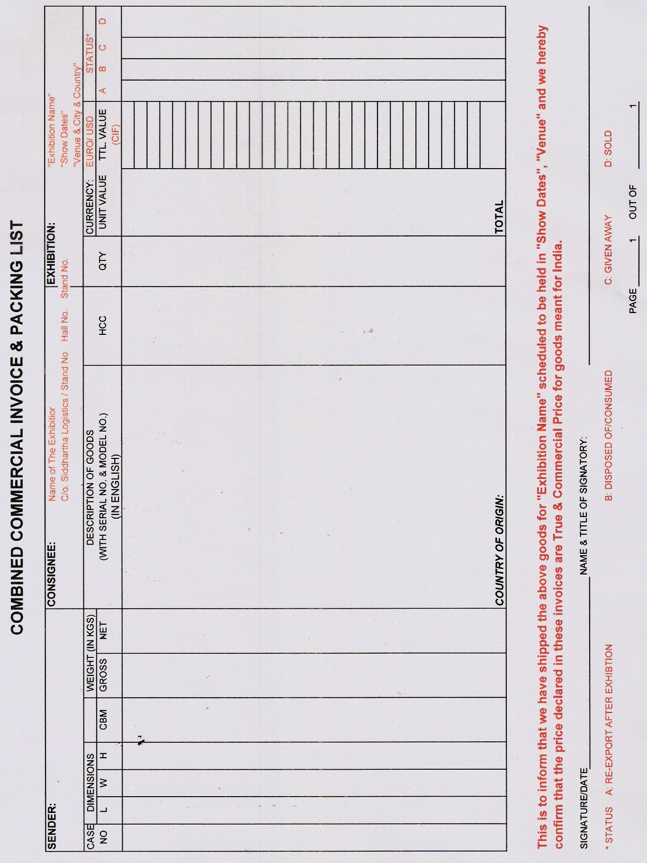
10.

